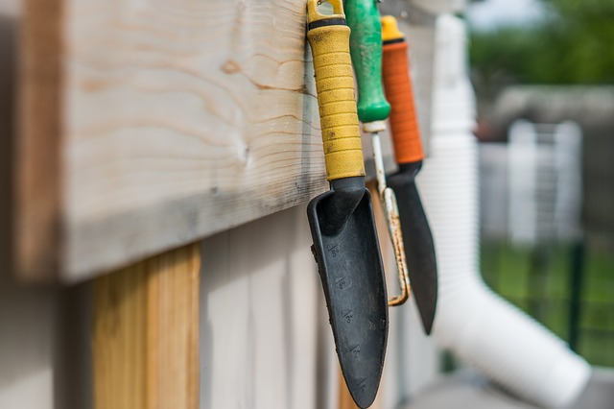
3-Seed Story Starter Guide
Dig-in to Design Your Best Life

Welcome!

We’re so glad you are investing in yourself and starting the journey toward a heart-centered creative life—your Whole Soul Life. You are not alone in taking this first step. We’ve all been there: stuck… distracted… discouraged. Overwhelmed by uncertainty and “if onlys.” The simple act of opening this document is courageous and creates energy and momentum. Can you feel it?

It All Starts with You and Your Enthusiastic “YES!”

There’s no better way to dig into this transitional season than by investing in yourself. The 3-Seed Story Starter offers a step-by-step guide to help you make a healthy, sustainable and fruitful investment in your life story.

Now is the time to “dig in.”

How to get started
- Read through the entire 3-Seed Story Starter Guide at least once to familiarize yourself with the concepts, terminology and tracking tool.
- All three seeds (steps) can be completed in less than ten minutes. If you have more time to spend on any of these steps, take it… and you’ll germinate gratitude. (We value fun, so look out for the pun… and the shameless exploitation of metaphors.)
- Print the 3-Seed Story Starter Tool.
- Gather the small list of supplies and review the decisions to make prior to Day-1 of this exercise.

Let’s plant some seeds!
Preparing to Sow the Seeds for Your Best Life Story

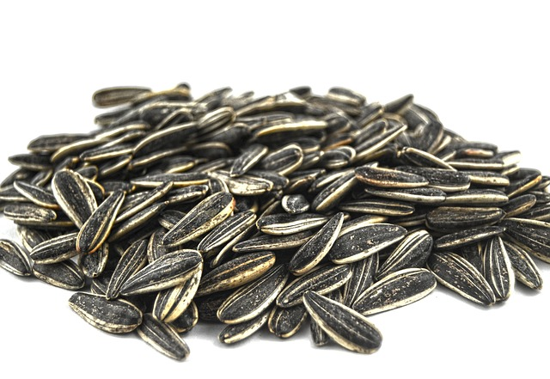
When you are living your best life story, the Whole Soul Story, you are connected to and living your purpose. You have FUN every day. You are doing things that bring joy to your soul. You are positively impacting the lives of the people around you.

You love your life again.

Are you thinking “Yes! I want that, but HOW?”

I’ve asked that same question… more than once in my life.

“How can I change my life, my circumstances, the way people see me?”

My responses ranged from reading yet another promising book about self-improvement and then beating myself up for not doing as it suggested. I also tried starting new habits around health or my dream of writing. But too often I watched the sparkling new habit fade away, blaming my life and people around me for preventing me from sticking with it.

Something was missing from all those attempts at trying to answer, “How?”

Then, on a cloudy August day a few years ago, I stood in a section of my garden and asked again, “How can I fix this? Is this it? Is this the way this part of my garden is meant to be?”

I looked at the other parts of my garden where vegetables and flowers grew in abundance. Then I looked back at the overused and undernourished soil, the barren patches and the spots where weeds were threatening to take over. I asked myself, “Can I change this? Maybe… but how?”

It was then I spotted a single wild sunflower blooming in the dry, rocky edges of my garden. I didn’t remember planting it... of course, I hadn’t. The wind, a bird or maybe a squirrel had placed the seed there.

The bloom was already starting to fade. How had I missed it?

How was the sunflower able to grow and push past the weeds? It had survived using only sunlight and the limited rainwater of my semi-arid climate. Incredible, but HOW had it done it?

The answer to all my questions was this: The sunflower was living into its purpose despite the less than ideal conditions. It knew its “why.”

When your “why” is big enough, you will figure out the “how.”
–Wise Person

I was asking the wrong question. I needed to ask myself, “Why?”

The sunflower, my questions and my garden blurred and then became a sharply focused analogy.

A single sunflower… just like my single purpose. Planted in me... in the place it is meant to grow. Waiting for its time to bloom. Waiting for me to see it. Waiting for me to be brave enough to call it by name.

If only I could find the courage to do the challenging work of answering, “Why?” I suddenly had hope that the “how” would follow.

My Soul’s Sunflower was waiting for me to prepare the soil so it could produce more blooms than I could ever imagine.

Preparing the Soil for Your Best Life Story
Your soul’s purpose was planted years ago in you. It’s probably bloomed from time-to-time since then.

We often sense its roots or see its buds during childhood—in moments of pure joy or crushing hardships.

“Every moment and every event of every man’s life on earth plants something in his soul.” –Thomas Merton

As adults, we can sense our purpose when we practice awareness. When we connect to our breath, special people or nature we are given glimpses of our purpose—in full bloom and colorful glory. Sometimes it appears in nudges or in a gradual unfolding of ideas.

Unfortunately, we are often too busy to notice. Too focused on the future harvest to notice the beauty and story of the present journey.

And yes, even in our pain, our purpose will try to reveal itself. Again, we are too often focused on the wrong places. We see the weeds (the disruptions) or the bare patches (the scarcity) and fail to notice the delicate sprouts fighting for our awareness. We long for the end of the painful, dry season and forget to tend the present soil.

In good times and in bad, we forget to look for the Soul’s Sunflower. We forget it can bloom in just about any conditions. But how many more blooms would there be if we tended the soil? How many lives beyond our own would be positively impacted?

A garden is only as good as its soil.

The best organic seeds will fail to grow and thrive in tired, overused and undernourished soil. Garden seeds require prepared soil: rested, hydrated, and nutrient-rich.

Your Whole Soul Garden Story is only as
good as your soul’s ‘why.’

To germinate and grow, Whole Soul Seeds require a prepared soul. One that is rested, hydrated and enriched. How’s your Whole Soul Garden soil?

We need to prepare both the soil and the soul.

“The beginning is the most important part of the work.” –Plato
The 3-Seed Story Starter Tool Overview

The 3-Seed Story Starter tool helps you create the habit of awareness. In order to reconnect to your life’s purpose, you need to make space in your life for it to reveal itself. You need to give it room to grow and you need to be on the lookout for its sprouts. By building your awareness, you are tending the soil. By saving space in your day for “soul work,” you are preserving room in your garden for your Whole Soul Story to grow.

The Three Seeds - Summary
- Breath Awareness: Numerous research-based studies document the benefits of focused breathing: decreased stress level, improved heart rate variability, reduced anxiety and depression levels, and lower blood pressure. HINT: It’s not the breath… it’s the awareness of your breath that is so powerful. (1-2 minutes)

- Movement: Focused, intentional movement brings awareness to what your body needs. It allows the body to wake itself using the energy stores from overnight. No jumping-jacks or treadmills required. (1-2 minutes)

- Affirmations: For simply mundane and scientific reasons, your world is created by your thoughts. You can either invest in your world or you can deprive it from what it could be. Affirmations build awareness which creates space for positive life change. (3-5 minutes)

The Tool’s Main Components
- Be More Aware: The memory prompt to help you recall the three seeds. Breath, Movement, Affirmations

- The 3-Seed Tracker Table: Where you build self-awareness and accountability for completing the daily seeds. You can also capture any inspirations or thoughts that unfold as you complete the daily seeds. (Available at the end of this document.)
Supplementary Components
- The 30-day Never Miss Twice Calendar: An easy and at-a-glance way to ensure you are building the 3-Seed habit by never missing two days in a row. Simply X-out the day you complete all three seeds… Never miss twice.

- The Dandelion List: A place to track those issues/obstacles that get in your way of completing the three seeds daily or living your purpose. False and negative thoughts are dandelions: “I’m not good enough” or “I’m weak” or “I should focus on losing weight, not breathing.” These thoughts definitely are holding you back, but for now, name them and add them to the dandelion list.

- The Debrief Table: Where you record any thoughts about what works or doesn’t work as you move through the 30-day tool. We recommend asking yourself the debrief questions at least once a week.

Master Gardener Tips
Throughout this document you will also find “Master Gardener Tips.” These are simple ideas to help you as you use the 3-Seed Story Starter Tool. You can also apply these concepts to your daily life.

You’ve been living life and creating your story since your first breath. You’ve seen successes and failures. You’ve tried new challenges and integrated lessons learned.

“A man sooner or later discovers that he is the master gardener of his soul, the director of his life.” –James Allen

YOU are the Master Gardener of your Life Story.

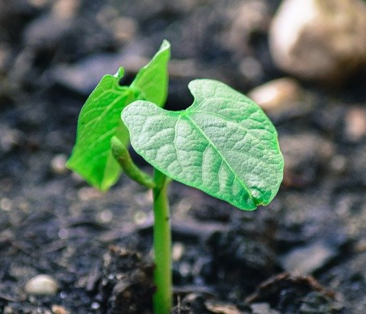
Master Gardener‘s Tip: Never Stop Learning

The Master of any creative endeavor must embrace the idea that learning never stops. The Master musician, sculptor or chef all know the secret to being a master is to continually look for opportunities to challenge themselves. Never stop learning.

The Italian phrase, “Ancora Imparo” means “Still, I am learning.” It has been attributed to the Master Artist and Sculptor, Michelangelo. Whether he uttered the phrase isn’t important. Instead, look at his life story. He lived a “Master’s” life. He never stopped learning and lived fully into his purpose.

His creative life provides the example the we too should never stop learning.

Master Gardener‘s Tip: Pick the Dandelions.

“Dandelions” are those issues or thoughts that pop up from time to time and distract us from more important matters. We struggle and fight to get rid of them until we’re either exhausted or a different dandelion captures our focus.

The problem with dandelions is this: they have deep roots and usually can’t be “fixed” in three days or three simple steps. However, when the soil is hydrated and loose, it’s much easier to extract them. The key is to first focus on the soil.

When a dandelion appears, you can minimize its impact by picking the flower and preventing it from spreading its seed. Instead, appreciate how the yellow bloom creates awareness of the issue. Set aside the issue for now by making a note of it on the Dandelion List. By first tending to your garden’s soil and your life story’s purpose, you will be better prepared to address the dandelions later.

Getting Started…
Prepare the Soil & Soul
Hydrate – Drink 1-2 glasses of water

After 7-9 hours of sleep, your body often needs rehydrating. I hear some of you laughing and thinking… “Seven hours? I’d love seven hours of sleep.” I’ve said that before, too.

It’s a Dandelion. Something to be aware of, but for now we’ll pick its bloom and make note of it in your 3-Seed Story Tracker. Then it’s back to preparing your garden’s soil.

Drinking one or two glasses of warm water first thing in the morning improves digestion and can jump-start your metabolism.

It also can help you build the routine of drinking water throughout the day.

More importantly, it creates an easy trigger for the first of your three seeds.

“Cheers” to starting your story. Drink up!

Master Gardener‘s Tip: Guidelines are Better than Rules

Keep in mind, the steps and details within this guide were intentionally chosen to best support your ability to design and live into your best life.

However, these are guidelines, not rules. Building on your own awareness allows you to determine what works best for your life.

For example, if warm water isn’t palatable for you, opt for room temperature. If planting your 3-seeds works better after the kids are off to school, do it then. If you want to add lemon to your morning water, do it!

If you find yourself resisting a particular step or detail, listen. It may be a dandelion in bloom.

The 3-Seed Story Starter Tool

Seed 1
Breath Awareness

Settle into your morning space. Whether you are in a chair or on the floor, feel the physical weight of your body as it supported by the surface beneath it.

Take a long slow inhale—this is preparing your body to give and receive the loving energy you are surrounded by. Exhale slowly.

Let’s begin:

- Inhale and silently say the words: I know that I am breathing in.
- Exhale and silently say the words: I know that I am breathing out.

Repeat the breath cycle and supporting sentences three times.

If other thoughts enter into your mind, use your breath and words to release them.

“Focus on the miracle that your breath is.” –Jacqueline Whitney
Seed 2
Movement
It’s time to build energy in the body through movement. The important concept in this step is to listen to your body. This is not the time to exercise—no vigorous, heart-pumping activity. You can build that into another part of your day.

This movement is intended to bring your awareness to what the body needs. This could vary from day-to-day.

Consider how a young child wakes. What movements do they do? Yawning, arm stretching, full-body stretches. The movements are slow with the intention of gently elongating the muscles. If you need a word to focus on, let it be “lengthening.”

If you are familiar with yoga practices, this is a good time to rest in child’s pose. If your body craves more, try doing a cat-cow sequence. Move with your breath… slowly.

“Nothing is more revealing than movement.” –Martha Graham

Find stillness again when your body is ready.

Seed 3
Affirmations

This seed requires more time to plant than the previous two. It also may take you a bit out of your comfort zone. But remember what that means—you are growing.

“Growth and comfort do not coexist.” –Ginni Rometty

Practicing positive affirmations is quite simple. You select a phrase and repeat it. For added benefit, write it down.

The benefits come from the consistency. The phrases selected within this step can be used anytime throughout the day, but starting your day with these key affirmations can help lower stress levels and increase your resilience.

Every morning you will write each of the following affirmations in the 3-Seed Story Starter tool:

Affirmation #1 | Thoughts for Consideration
I am awake. | It’s morning… of course we’re awake. But take the time remind yourself. You’re awake and have been given the gift of another day. Feel your breath as you say this out loud and write it down. Feel your pen move across the page. Short and sweet, but powerful and effective.
Affirmation #2
I am aware of my breath. | This is one affirmation with five parts. Breathe in and breathe out. Write the affirmation down as you say it. Repeat it five times, but change the last word with each inhale/exhale.
I am aware of my senses. | For senses: Consider your five senses. What do you see, hear, smell, feel and taste in this moment? It’s a quick scan of your physical presence.
I am aware of my thoughts. | For thoughts: Are there any ideas nudging you? Maybe a negative thought that is not true? Embrace and release any thoughts that arise. Simply notice them without judgment.
I am aware of my emotions. | For emotions: What are the feelings in your gut or heart at the moment? Are they leftover emotions from yesterday or last week? Are they fresh with this new day? Again, simply notice and release them.
I am aware of my energy. | For energy: How would you describe the energy flowing through you? Is it calm or electrified? Does it appear as a color or do you experience it as a vibration? Notice and release.
Affirmation #3
I am present. | As you write and speak this affirmation, notice the surface supporting you. Go beyond the physical surface your body is in contact with. Can you sense the support beams in the floor beneath you or the earth beneath that?  Notice your awareness. Remind yourself what a gift being present in this day is.

Bonus Master Gardener‘s Tip:
Watch out for the Double-Dandelion

The Double-Dandelion of Isolation and Overwhelm can take over your garden in a blink. Be on the lookout. Notice it and welcome the two-fold awareness it brings.

You pluck the flower of isolation by surrounding yourself with individuals or a community of like-minded people whom you can turn for support and accountability. But don’t just select anyone. Be mindful. You will need people who will offer encouragement on the cloudy days and hold you accountable even on the sunny days.

You pluck the flower of overwhelm by doing what you can do with the energy and resources you have today. Most seeds take 10-14 days to reveal the beginnings of a sprout. As you plant these Whole Soul Seeds, you may see changes in your life right away or it may take the full thirty days. Be patient. Take it one day at a time. Trust the seeds you plant are breaking open, growing roots and ready to send up shoots. The gardener has to trust what is happening to the seed while it remains hidden in the soil.

Stay connected and practice patience.

It’s time to plant seeds and write your new life story.
(You’ll find the 3-Seed Story Starter Tool at the end of this document.)

“The most important story we’ll ever write in life is our own—not with ink, but with our daily choices.” –Richard Paul Evans

It All Starts with You and Your Enthusiastic “YES!”

Dig-in and Discover Your Next Steps.

I'd be honored to help you define your next steps, so you can begin moving from where you are now in your life to where you want to be – without the overwhelm or fear.

You're invited to join me for a complimentary, no-obligations Strategy Session, where together, we will:

- Explore the goals you want to achieve to create the life you love.
- Identify the obstacles you currently face.
- Define next steps to overcome those obstacles on your journey toward greater fulfillment.
- Make powerful forward progress, so you can begin living your ideal creative life and making a positive impact on the world.

Plant the Seeds
&
Step into Your Story

Take the next step. Click this link to schedule your Complimentary Open the Gate to Change Strategy Session

No tool, book or person changes your life.
They simply make you aware of how you might be able to change it.

Instructions/Notes
- Gather the following:
  - A pen
  - The 3-Seed Story Starter Tool
- Drink 1-2 glasses of water to waken and hydrate your body.
- Find a quiet place where you won't be interrupted for at least 10 minutes.
- Using good posture, get comfortable and grounded.
- Take 3-5 minutes for the Affirmations Seed and 1-2 minutes on the rest.
- Take 1-2 minutes to debrief your thoughts below(at least once a week):

Never Miss Twice Tracker | Dandelion Disruptions
Place an X through the days you complete the three seeds.
1 | 2 | 3 | 4 | 5 | 6
7 | 8 | 9 | 10 | 11 | 12
13 | 14 | 15 | 16 | 17 | 18
19 | 20 | 21 | 22 | 23 | 24
25 | 26 | 27 | 28 | 29 | 30

What worked? (+) | What didn’t work? (-) | What would I do differently? (+/-)

 |  | Be More Aware
Seed | 0 | 1 | 2 | 3 | Sprouts
Day | Water | Breath | Move | Affirmations | Thoughts
 | o o | o o  o | o | - I am awake.  - I am aware of my breath.  I am aware of my senses, thoughts,  emotions, energy.  - I am present.
¹ | o o | o o  o | o
² | o o | o o  o | o
³ | o o | o o  o | o
⁴ | o o | o o  o | o
⁵ | o o | o o  o | o
⁶ | o o | o o  o | o
⁷ | o o | o o  o | o
⁸ | o o | o o  o | o
⁹ | o o | o o  o | o
¹⁰ | o o | o o  o | o
¹¹ | o o | o o  o | o
¹² | o o | o o  o | o
¹³ | o o | o o  o | o
¹⁴ | o o | o o  o | o
¹⁵ | o o | o o  o | o
¹⁶ | o o | o o  o | o
¹⁷ | o o | o o  o | o
¹⁸ | o o | o o  o | o
¹⁹ | o o | o o  o | o
²⁰ | o o | o o  o | o
²¹ | o o | o o  o | o
²² | o o | o o  o | o
²³ | o o | o o  o | o
²⁴ | o o | o o  o | o
²⁵ | o o | o o  o | o
²⁶ | o o | o o  o | o
²⁷ | o o | o o  o | o
²⁸ | o o | o o  o | o
²⁹ | o o | o o  o | o
³⁰ | o o | o o  o | o

^{Day 30+} | CONGRATULATIONS! You just completed the  30-day Seeds to Stories 3-Seed Story Starter!

You are on your way to designing and living a life you love.
Keep the momentum flowing.

You're invited to join me for a complimentary, no-obligations Strategy Session, where together, we will:

- Explore the goals you want to achieve to create the life you love.
- Identify the obstacles you currently face.
- Define next steps to overcome those obstacles on your journey toward greater fulfillment.
- Make powerful forward progress, so you can begin living your ideal creative life and making a positive impact on the world.

Take the next step. Click this link to schedule your Complimentary Open the Gate to Change Strategy Session

To build momentum for your epic life story: SeedstoStories.com/Seeds

